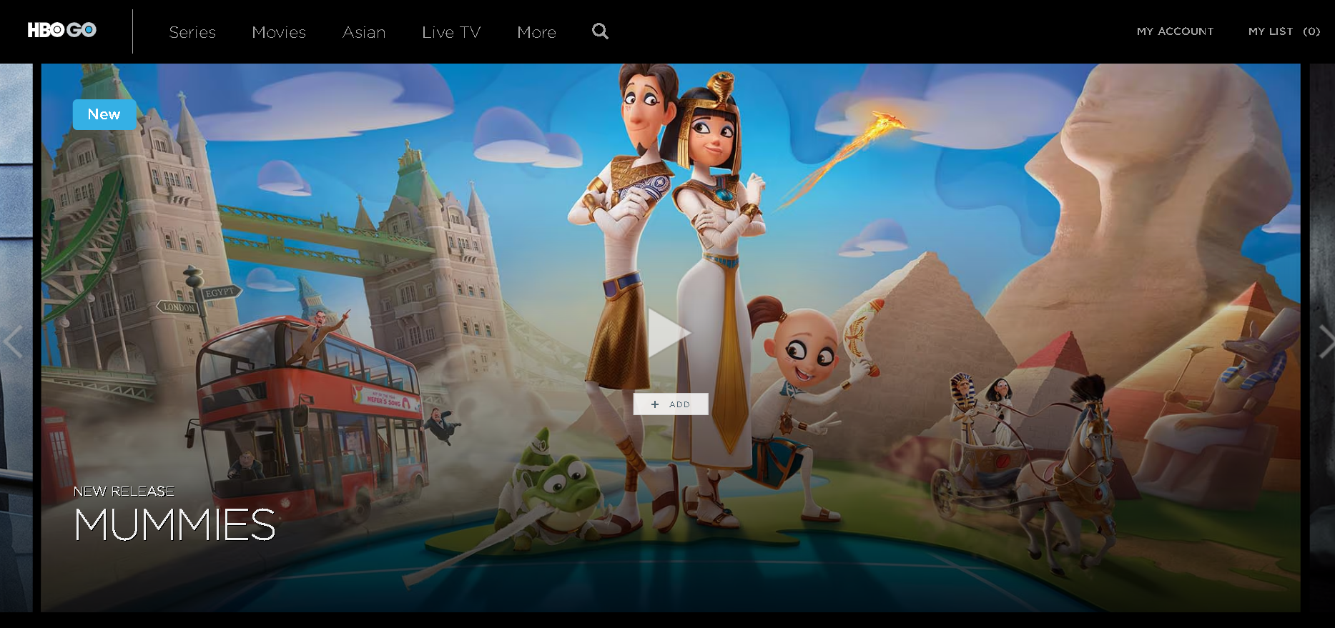

**HBO GO ASIA REDESIGN**

**Project Idea:**

Reinvent existing famous & giant applications (ex. Zoom, Facebook, AirBnB, etc.).

**Technologies:**

1. HTML

2. CSS

3. REACT.JS

4. TMDB API

5.. AXIOS

6. MATERIAL -UI

**Features:**

1. More friendly user
2. Users can browse and watch movies of their choice.
3. User can register and log in to the website.
4. Upon Sign in and Sign up, the User already sees the validation errors upon typing on the input box and is able to correct the inputted information right away.
5. User information are stored on JSON SERVER rest API, and you can retrieve as well.
6. Users information also passed to SessionStorage to keep the user logged in even the page was refreshed.
7. The User can see their account information on MyAccount tab.
8. User can easily navigate into the website.

Trello Link :

<https://trello.com/invite/b/xilsTSSW/ATTIe2b27d3e304c8e0a8d26b24ac14cf50d36D164CD/capstone>

Video Demo Link:

<https://youtu.be/4rQU25HSHUY>